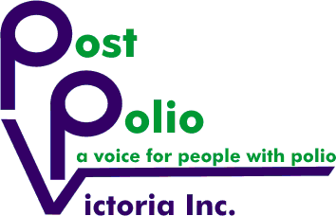

POST POLIO VICTORIA INC.
ANNUAL GENERAL MEETING
will be held on
Thursday 25th November 2021
7.00 PM
Due to the impact of the COVID-19 pandemic, the AGM will be conducted via Zoom
Please register here: https://www.trybooking.com/BVDMY

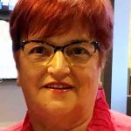
The formal Annual General Meeting will be followed by guest speaker

Past District Governor (PDG) Lion Patricia Mills R.N (Retired)
Cabinet Chair for Lions District 201V5 Including Diabetes and Childhood Cancer Research

Topic:
Partnership - PPV and other Volunteer Organisations. Learning how Lions create neutral outcomes through Not for Profits via the UN allowing all to have a voice and help change the direction of many humanitarian projects.

Please contact PPV if you have any questions or concerns
info@postpoliovicotria.org.au
or phone PPV on 0431 702 137.

Questions post formal AGM completion are welcome

We would really like you to join us in our mutual journey!
Thank you

